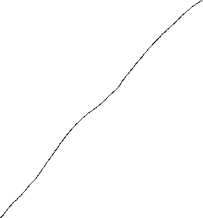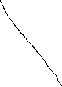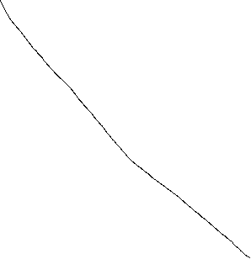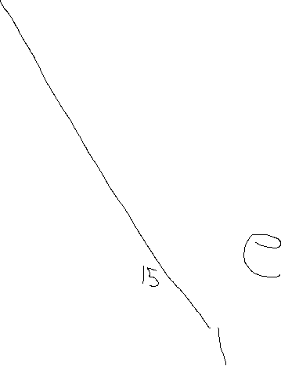

1. Este grafo tiene camino euleriano
2. Grado(M) + grado(a) ≥ 6-1  
   b + f = 5 ≥ 5 : V  
   b + e = 6 ≥ 5 : F   
   Como b + e es mayor que 5 entonces no cumple la condición de ore.
3. Camino más corto de b hasta f:

|  |  |  |  |  |  |  |  |
| --- | --- | --- | --- | --- | --- | --- | --- |
| Paso | a | b | c | d | e | f | Ruta: Peso |
| I | ∞ | 0 | ∞ | ∞ | ∞ | ∞ | b: 0 |
| II | 5 | - | 4 | 1 | ∞ | ∞ | b-d: 1 |
| III | 5 | - | 4 | - | 7 | ∞ | b-c: 4 |
| IV | 5 | - | - | - | 6 | 5 | b-c-f: 5 |
| V | - | - | - | - | - | - |  |

1. Algoritmo del camino más corto:

|  |  |  |  |  |  |  |  |  |
| --- | --- | --- | --- | --- | --- | --- | --- | --- |
| Paso | a | b | c | d | e | f | g | Ruta: peso |
| I | 0 | ∞ | ∞ | ∞ | ∞ | ∞ | ∞ | a: 0 |
| II | - | 2 | 8 | ∞ | ∞ | 20 | 5 | a-b: 2 |
| III | - | - | 7 | 5 | 13 | 20 | 5 | a-b-d: 5 |
| IV | - | - | 7 | - | 9 | 20 | 5 | a-b-c:7 * |
| V | - | - | - | - | 9 | 20 | 5 | a-b-c-e: 9 |
| VI | - | - | - | - | - | 19 | 5 | a-b-c-e-f: 19 |

1. Circuito de Euler: A - B – D – E – B – C – A – G – E – F - A

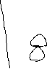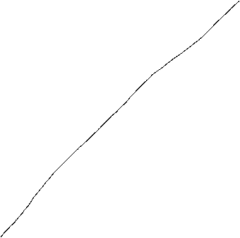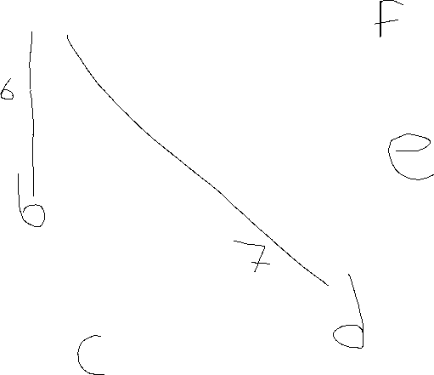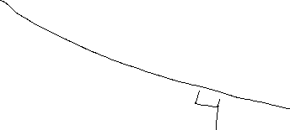

1. Camino de Euler: B – A – D – E – F – E – D – C – F – B
2. No hay
3. Algoritmo del camino mas corto de a – f

|  |  |  |  |  |  |  |  |
| --- | --- | --- | --- | --- | --- | --- | --- |
| Paso | a | b | c | d | e | f | Ruta : peso |
| I | 0 | ∞ | ∞ | ∞ | ∞ | ∞ | a:0 |
| II | - | 6 | ∞ | 7 | 9 | 20 | a-b:6 |
| III | - | - | ∞ | 7 | 8 | 15 | a-d:7 |
| IV | - | - | 8 | - | 8 | 15 | a-d-c:8 |
| V | - | - | - | - |  | 11 | a-d-c-f:11 |

Allan Robinson Parkinson Quiz #3   
Estructuras Discretas   
Profesor: Eithel Trigueros Rodríguez   
Ciclo I 2024 Nivel II